Contents
Age Test – Game Description 1
Main Features 1
Gameplay Experience 2
Purpose of the Game 2

Table of contents
Figure 1 home page 3
Figure 2 gameplay page 4
Figure 3 gameplay page 4
Figure 4 analysing the answers in the gameplay 5
Figure 5 final answer 6

Age Test – Game Description
Age Test is an entertaining and interactive quiz game designed to determine how old I truly am based on my lifestyle, personality, habits, and opinions. The game asks players a series of fun and creative questions about their daily routines, emotions, preferences, and behavior patterns. Using the answers provided, the game analyses the player’s personality and calculates an estimated “mental age” or “behavior age.”
Unlike traditional quiz games that focus on knowledge or right and wrong answers, Age Test is all about self-expression and personality analysis. Every question helps build a profile of the player’s lifestyle and mindset. Questions can range from sleeping habits and school opinions to social behavior, hobbies, food preferences, and reactions to different situations.
Examples of questions include:
There are 30 questions in this game. Such as
- What time do you usually wake up in the morning?
- How do you feel when you get homework?
- What do you normally do on weekends?
- How late do you stay awake at night?
- How often do you use social media or play games?
- What kind of music or movies do you enjoy?
The game uses a scoring and analysis system that compares the player’s answers with different personality and age-related patterns. At the end of the quiz, the player receives a detailed result explaining whether they behave younger, older, or close to their real age. The result may include fun comments, personality insights, and humorous feedback to make the experience more engaging and enjoyable.

Main Features
- Fun and easy-to-play quiz gameplay
- Personality and lifestyle-based questions
- Smart age analysis system
- Instant results with detailed feedback
- Multiple categories of questions
- Suitable for teenagers and adults
- Replayable with different outcomes

Gameplay Experience
The game creates a relaxed and entertaining atmosphere where players can answer honestly and compare results with friends or family. Since every answer changes the final analysis, each playthrough can feel unique and interesting. The game encourages curiosity and social interaction while giving players amusing insights into their habits and personality.

Purpose of the Game
The purpose of Age Test is to provide a fun self-discovery experience through interactive quizzes. It combines entertainment, psychology-inspired analysis, and daily life questions to create a game that is both enjoyable and engaging for players of all ages.

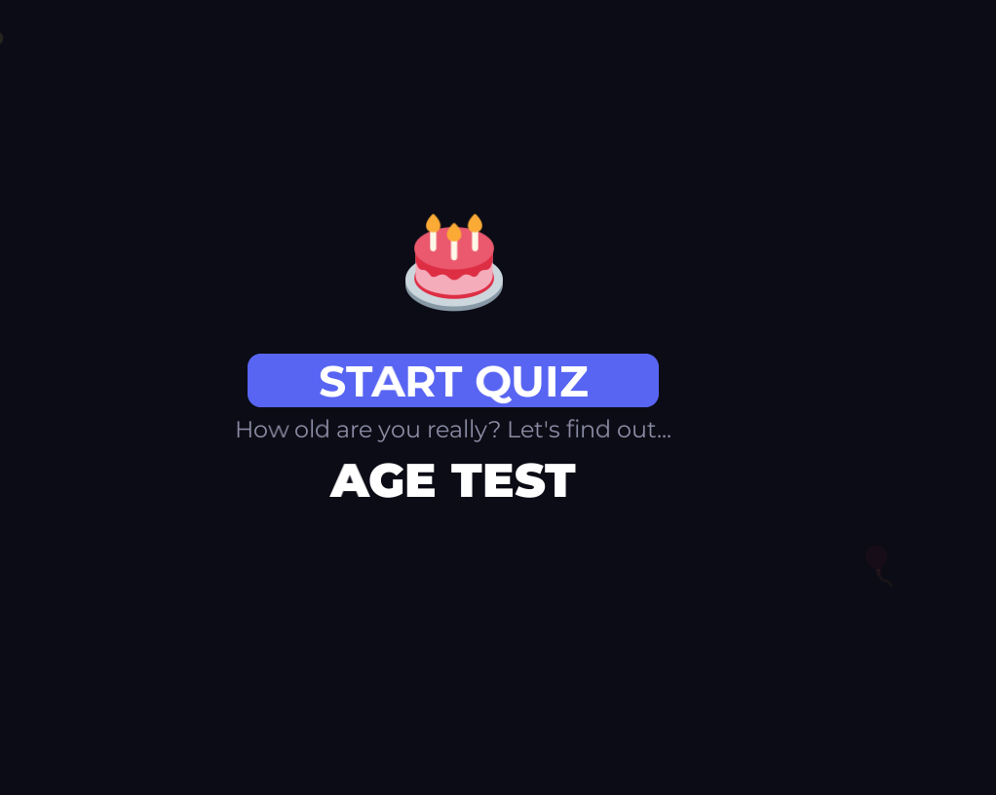
Figure 1 home page

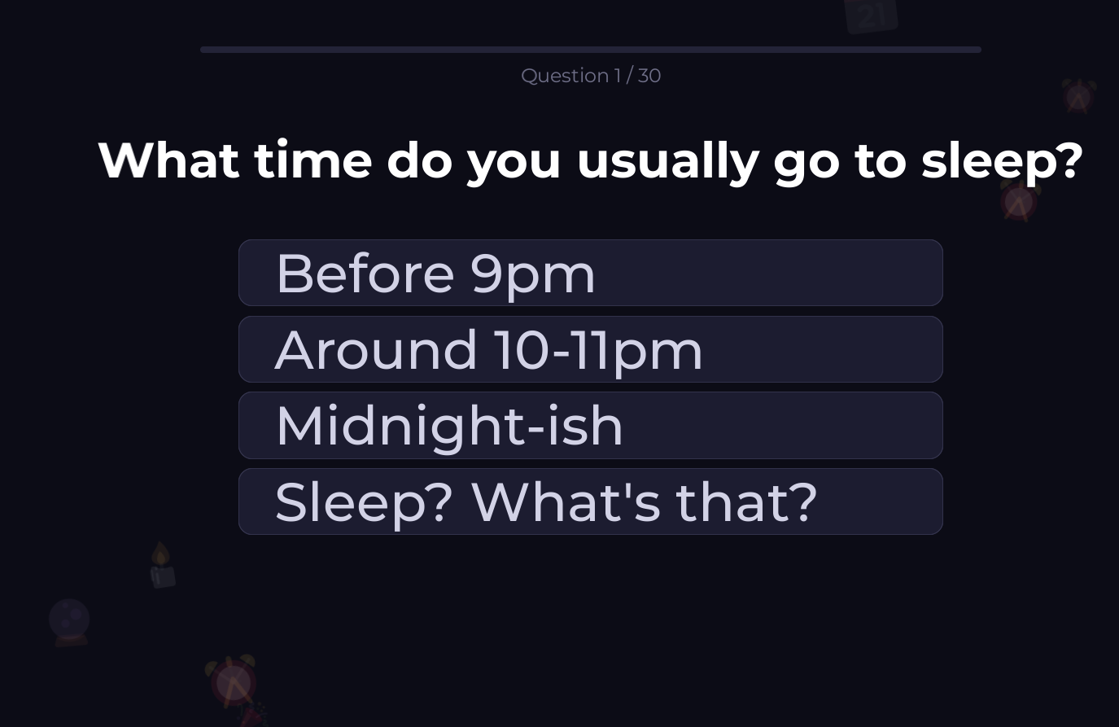
Figure 2 gameplay page

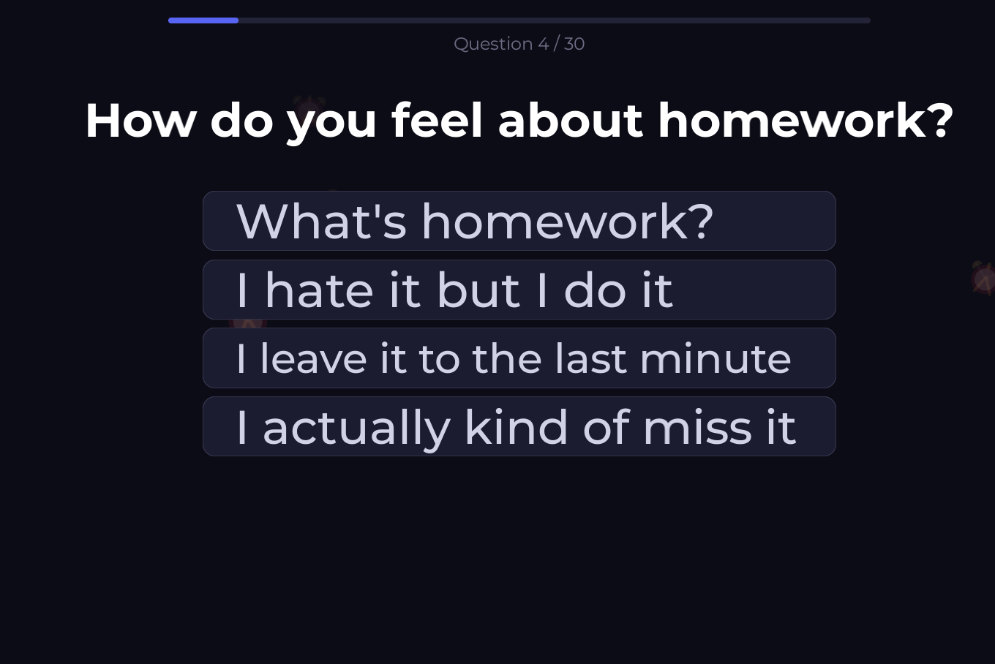
Figure 3 gameplay page
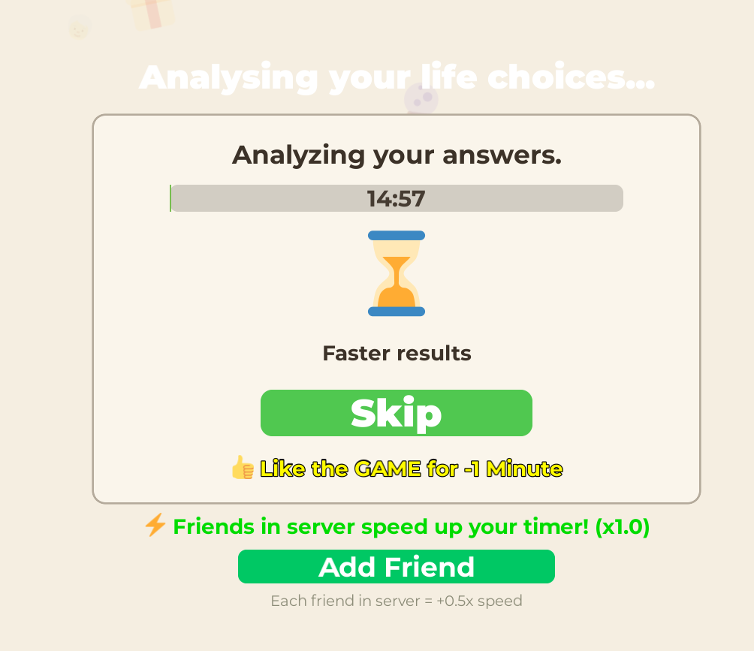
Figure 4 analysing the answers in the gameplay
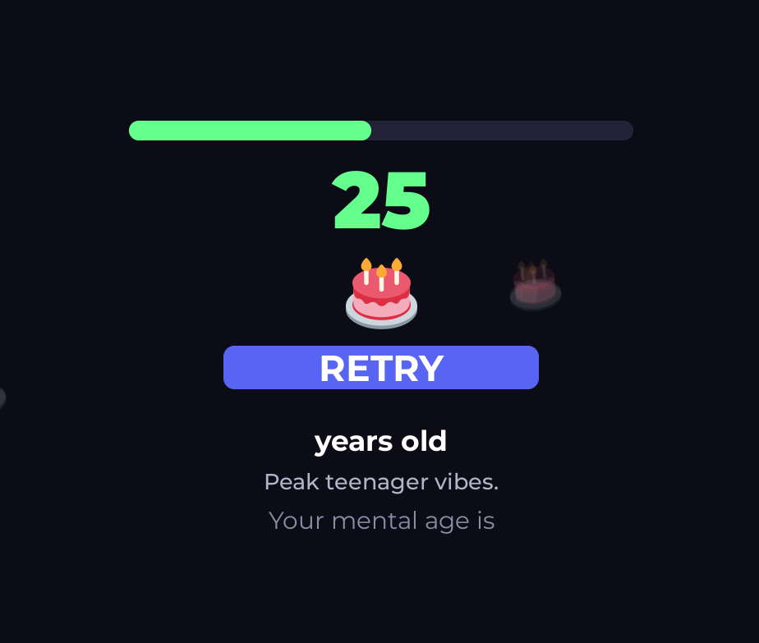
Figure 5 final answer

